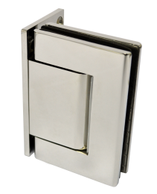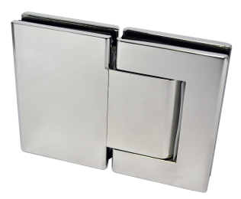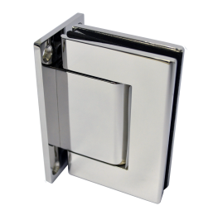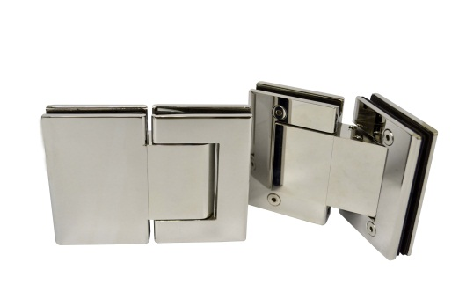

**P&M** **HX Hinges for Entrance Door**

*Hydraulically Controlled Self-Closing Hinges*

**P&M** HX hinges allow the design possibilities of avoiding messy hacking of concrete floor to receive door closer. Without the cover plate for the floor closer, the uniformity of the floor finish is maintained.

It is ideal for offices and homes, where the need for a hydraulic controlled hinged glass doors is even more pronounced. Widely specified by architects and designers for use in entrance glass door for wet kitchen, wash areas, poolside fencings, as the best solution to the common problem of water seepage into the cement box of a floor closer.

**P&M** HX Hinges are available in wall mount, offset wall mount and 180° glass to glass fixing. Made of high quality SUS304 stainless steel in satin finish.